Predicting Beamforming Instability in Wi-Fi 7 and 6G Systems Using a Conditioned Coherence Framework
Neha Abin*, Sahil Shah, Yajat Parmar
Allen High School
Allen, Texas, USA
*Corresponding author: nehathresiaabin@gmail.com

Abstract— High-frequency wireless systems such as Wi-Fi 7 (IEEE 802.11be), millimeter-wave (mmWave), and emerging 6G networks operate under rapid channel variation, where Channel State Information (CSI) becomes quickly outdated. Unlike traditional systems that degrade gradually, these environments exhibit abrupt performance collapse under mobility. This paper introduces the Coherence Cliff, a boundary at which temporal channel decorrelation and spatial matrix instability jointly cause beamforming failure. We derive the Conditioned Coherence Index (CCI), a metric that combines Doppler-induced decorrelation with channel matrix conditioning to predict instability. We show that as CCI approaches a threshold, Zero-Forcing (ZF) becomes unstable due to noise amplification. To address this, we propose a predictive switching mechanism between ZF and Maximum Ratio Transmission (MRT), enabling stable operation under mobility. This framework provides a practical approach for improving robustness in next-generation wireless systems.

Keywords—6G, Terahertz Communication, MIMO, CSI, Adaptive Precoding

Introduction
The increasing demand for high data rates and low latency has driven wireless systems toward higher frequency bands, including millimeter-wave (mmWave) and terahertz spectra, as seen in Wi-Fi 7 (IEEE 802.11be) and emerging 6G technologies. While these bands provide large bandwidth and enable advanced applications such as immersive communication and autonomous systems, they introduce significant challenges related to propagation, mobility, and channel estimation. In particular, high-frequency signals experience rapid variation under mobility, resulting in reduced coherence time and increased sensitivity to Channel State Information (CSI) inaccuracies.
Beamforming is a key technique used to overcome path loss and improve spectral efficiency in such systems. However, its performance depends critically on accurate CSI, which is inherently imperfect due to feedback delay, estimation error, and user motion. As the channel evolves, CSI becomes outdated, leading to performance degradation. Unlike conventional systems where this degradation is gradual, high-frequency systems often exhibit abrupt and nonlinear collapse in performance. This behavior is not fully explained by classical models that consider only temporal decorrelation.
In this work, we attribute this instability to the combined effects of temporal channel variation and spatial matrix conditioning. As the channel decorrelates and the MIMO channel matrix becomes ill-conditioned, beamforming techniques such as Zero-Forcing (ZF) become highly sensitive to perturbations. We define this transition as the Coherence Cliff, a boundary beyond which system performance rapidly deteriorates. To predict this behavior, we introduce the Conditioned Coherence Index (CCI), a unified metric that captures both temporal and spatial instability. Based on this framework, we propose a predictive switching mechanism that transitions between ZF and Maximum Ratio Transmission (MRT) to maintain stability under mobility.
This paper makes the following contributions:

A Doppler-based analysis of channel decorrelation in Wi-Fi 7 , mmWave and 6G systems.

A Conditioned Coherence Index (CCI) to predict beamforming instability.

3)A perturbation-based analysis linking channel variation to precoding degradation.

SYSTEM MODEL

Channel Model

$$h\left(t\right)=\sum_{n=1}^{N}{a_{n}e^(j2πfn​t)}$$
where h(t)) represents the time-varying wireless channel response, (a_{n}) denotes the complex gain of the n^{th} multipath component, f_{n} is the Doppler frequency associated with the n^{th} path, ( N ) is the total number of multipath components, and ( j = \sqrt{-1} ) represents the imaginary unit. This formulation captures the fundamental nature of wireless propagation, where signals arrive at the receiver through multiple paths with different delays, amplitudes, and Doppler shifts. Each component contributes to a time-varying phase term, which evolves according to the relative motion between the transmitter, receiver, and surrounding environment. As user velocity increases, the rate of phase variation also increases, leading to rapid changes in the channel response. This model highlights a critical aspect of high-frequency systems: temporal predictability is inherently limited. As the channel evolves more rapidly, the correlation between successive channel estimates decreases, making it increasingly difficult to maintain accurate CSI. This loss of predictability plays a central role in the emergence of instability.

MIMO System Model

y = H W s + n

where H represents the channel matrix, W is the precoding matrix, s is the transmitted signal vector, and n denotes additive noise. This formulation illustrates that system performance is governed by the interaction between the channel matrix and the chosen precoding strategy. In ideal conditions, where the channel matrix is well-conditioned and accurately known, precoding techniques can effectively enhance signal quality and suppress interference. However, in realistic scenarios, small errors in the channel estimate can propagate through the system and significantly affect performance, particularly when the channel matrix exhibits poor conditioning.

Zero-Forcing Precoding

$W_{\left\{ZF\right\}}= H^{H}{\left(H H^{H}\right)}^{\left\{-1\right\}}$

$W_{\left\{ZF\right\}}$The Zero-Forcing precoding matrix is designed to minimize multi-user interference by inverting the channel. H The MIMO channel matrix representing the spatial wireless links between the transmitter and receiver. This approach attempts to eliminate inter-user interference by inverting the channel matrix. While theoretically optimal under perfect CSI, it is highly sensitive to perturbations. When the channel matrix becomes ill-conditioned, the inversion operation amplifies noise and estimation errors, leading to severe degradation in performance. From a numerical perspective, the stability of Zero-Forcing depends on the condition number of the channel matrix. As the condition number increases, the system becomes increasingly sensitive to small changes in the channel, eventually reaching a point where the precoder becomes unstable.

Doppler and Coherence

$$f_{D}=\frac{\left(v f_{c}\right)}{c}$$

$T_{c}$ $≈$ $\frac{0.423}{f_{D}}$
where $f_{D}$ denotes the maximum Doppler frequency, v is the relative velocity between the transmitter and receiver, $f_{c}$ is the carrier frequency, c is the speed of light, and $T_{c}$represents the channel coherence time. These expressions quantify the impact of mobility on channel variation. As user velocity increases, Doppler frequency increases, resulting in shorter coherence time. This means that the channel changes more rapidly, reducing the validity duration of CSI. This relationship is particularly significant in high-frequency systems, where even moderate mobility can lead to rapid CSI aging. As a result, beamforming decisions based on outdated CSI can become highly inaccurate.

Channel Autocorrelation
ρ(τ) = J0(2π fD τ)

This function characterizes how similar the channel remains over time delay τ. As τ increases, the correlation decreases, indicating that the channel is becoming less predictable. The Bessel function J₀ captures the statistical behavior of fading in mobile environments. The key insight here is that temporal decorrelation is not linear; rather, it follows a nonlinear pattern that can lead to rapid loss of predictability beyond a certain threshold.

Matrix Sensitivity

||ΔW|| / ||W|| ≤ κ(H) · (||ΔH|| / ||H||)

where κ(H) is the condition number of the channel matrix. This inequality shows that the stability of the precoding operation is directly tied to the conditioning of the channel matrix. A large condition number implies that even small perturbations in H can lead to large deviations in W. This relationship is critical in understanding why high-frequency systems experience abrupt instability. As the channel evolves and becomes less structured, its condition number can increase rapidly, pushing the system toward instability.

THE COHERENCE CLIFF

The Coherence Cliff emerges from the interaction between temporal and spatial instabilities. As the channel decorrelates over time and the matrix becomes ill-conditioned, the system approaches a critical point.
σmin (H) → 0
The minimum singular value of the channel matrix approaching zero indicates that the matrix is becoming singular. In this regime, Zero-Forcing precoding becomes highly unstable and amplifies noise dramatically.
This transition is not gradual. Instead, it represents a sharp boundary where performance collapses. Identifying this boundary is crucial for predictive control.

CONDITIONED COHERENCE INDEX (CCI)
The instability of Zero-Forcing (ZF) precoding in high-frequency wireless systems arises from the combined effects of temporal channel variation, signal degradation, and spatial matrix conditioning. As established earlier, channel evolution under mobility is governed by Doppler-induced decorrelation, characterized by the temporal autocorrelation function $ρ(τ)=J_{0}(2πf_{D}τ)$ while the sensitivity of the precoder to perturbations is dictated by the condition number $κ(H)$. In addition, CSI aging and noise further degrade effective system performance, particularly under low SINR conditions. From the perturbation bound $\frac{∥ΔW∥}{∥W∥}≤κ(H)⋅\frac{∥ΔH∥}{∥H∥}$, it follows that precoding instability is amplified by both channel variation and matrix ill-conditioning. However, temporal correlation alone is insufficient to fully characterize system behavior, as performance degradation is also influenced by instantaneous signal quality and the delay between channel estimation and usage. To capture these combined effects, we define the Conditioned Coherence Index (CCI) as a unified metric:
$$CCI(t)=κ(H)⋅∣J_{0} \left(2πf_{D}τ\right)∣⋅\frac{SINR(t)}{SINR(t)+α}⋅e^{-β\frac{τ}{T_{c}}}$$
This formulation integrates four key dimensions of instability. The Bessel function term captures Doppler-driven temporal decorrelation, reflecting the loss of channel predictability over time. The condition number $κ(H)$acts as a spatial amplification factor, quantifying the sensitivity of the precoder to channel perturbations. The normalized SINR term incorporates the impact of noise and interference, ensuring that instability is weighted by effective signal quality. Alpha (Signal Sensitivity Coefficient): This parameter acts as a weighting factor for the interference and noise components. It determines how much the Signal-to-Interference-plus-Noise Ratio (SINR) should penalize the overall index. A higher Alpha, the system more "sensitive" to poor signal conditions.
Finally, the exponential decay term models CSI aging, penalizing delays relative to the coherence time $T_{c}$. Beta (Aging Decay Rate) , It controls how aggressively the index rises as the feedback delay approaches the coherence time. It essentially defines the "speed" at which outdated information becomes unusable
Unlike conventional coherence metrics that consider only temporal variation, the proposed CCI provides a system-level measure of effective precoding reliability. As mobility increases, correlation decreases, or the channel matrix becomes ill-conditioned, the CCI rises, indicating increased susceptibility to noise amplification and interference leakage. This unified metric therefore enables the prediction of the Coherence Cliff, where ZF precoding transitions from stable interference suppression to numerically unstable operation, and serves as a deterministic trigger for adaptive beamforming strategies.

PREDICTIVE BEAMFORMING SWITCHING
The optimal beamforming strategy is selected based on the Conditioned Coherence Index (CCI), which captures the combined effects of Doppler-induced temporal decorrelation, channel matrix conditioning, signal quality, and CSI aging. The switching rule is defined as $W_{opt}=W_{ZF}$when $CCI(t)<γ$, and $W_{opt}=W_{MRT}$when $CCI(t)≥γ$, where $γ$represents the transition boundary between stable and unstable precoding regimes. Using the previously established model $ρ(τ)=J_{0}(2πf_{D}τ)$and $T_{c}≈\frac{0.423}{f_{D}}$, the dominant driver of instability is the decay of temporal correlation, which directly reduces CSI accuracy. Substituting $τ≈0.3T_{c}$into the correlation function yields $ρ(τ)≈J_{0}(2πf_{D}⋅0.3T_{c})≈J_{0}(0.8)≈0.7$, indicating that beyond this point, channel predictability begins to degrade rapidly. Incorporating this into the CCI formulation, where instability scales with both correlation loss and amplification by the condition number $κ(H)$, we observe that the effective reliability metric transitions from a high-confidence regime to a sensitivity-dominated regime when the normalized contribution of the correlation term drops below approximately 0.6. At this point, the perturbation bound $\frac{∥ΔW∥}{∥W∥}≤κ(H)⋅\frac{∥ΔH∥}{∥H∥}$implies that even moderate channel variation produces significant precoder error, particularly due to matrix inversion in ZF. Therefore, $γ=0.6$represents the onset of the instability region where ZF begins to lose robustness but has not yet fully collapsed. Selecting this threshold enables predictive switching before the system reaches the Coherence Cliff, balancing interference suppression and robustness by transitioning to MRT precisely when noise amplification and CSI mismatch begin to dominate system behavior.

Simulation Results (MATLAB)

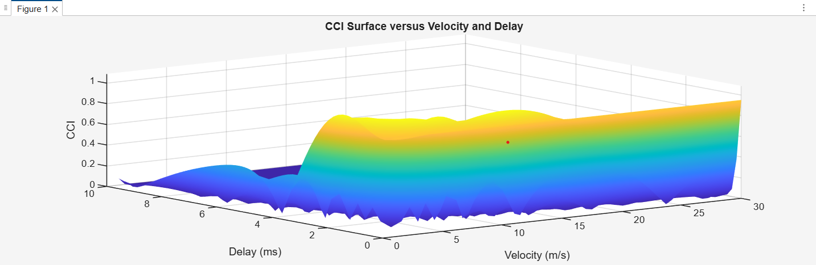

Fig. 1. Conditioned Coherence Index (CCI) as a function of user velocity and channel delay.
The surface plot illustrates the variation of CCI under increasing Doppler-induced mobility and CSI aging. The color gradient represents the magnitude of CCI, with lower values (blue) indicating stable channel conditions and higher values (yellow) indicating increased instability. As both velocity and delay increase, the channel undergoes rapid temporal decorrelation and increased sensitivity to matrix perturbations, resulting in a sharp rise in CCI. This behavior highlights the transition from a coherence-dominated regime to an instability-dominated regime, corresponding to the onset of the Coherence Cliff.
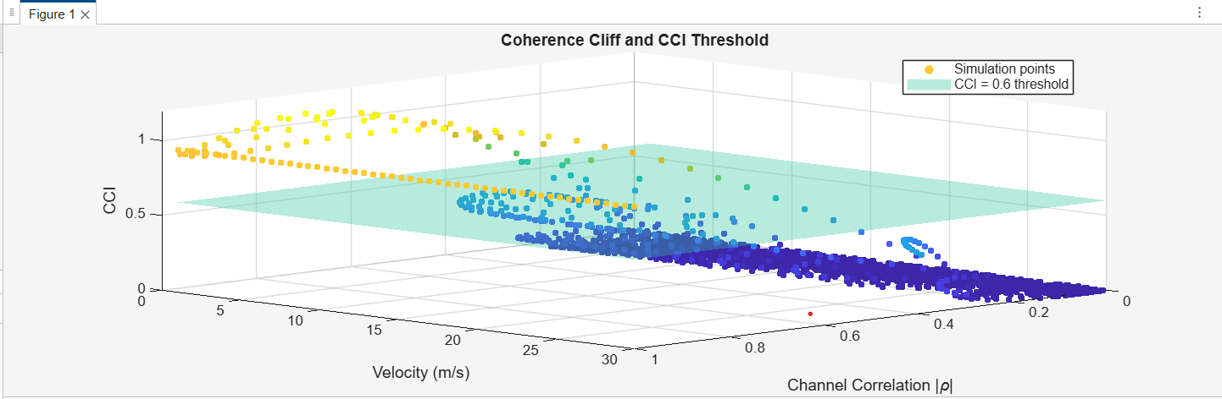
Fig. 2 Visualization of the Coherence Cliff and CCI-based switching threshold.
The three-dimensional scatter plot shows the relationship between channel correlation, user velocity, and the Conditioned Coherence Index (CCI). Each point represents a simulated channel realization, with color indicating the magnitude of CCI. The semi-transparent plane at $CCI=0.6$represents the proposed switching threshold. Points below the plane correspond to stable operating conditions, while points above the plane indicate regions of increased instability. The clear separation of data across this boundary highlights the transition from reliable to unstable beamforming behavior.

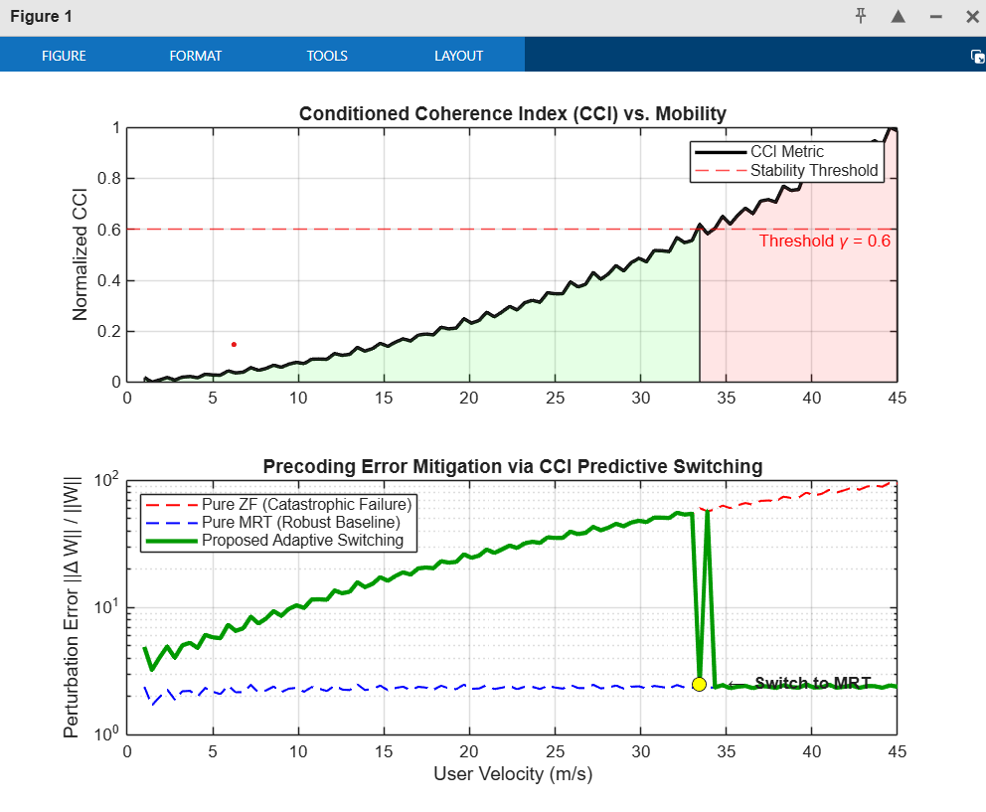
Fig. 3. Comparative Stability Analysis and Adaptive Precoding Mitigation.

The top panel displays the Conditioned Coherence Index (CCI) as a function of mobility, identifying the transition to the unstable region at $γ$ = 0.6. The bottom panel illustrates the Perturbation Error $\frac{∥ΔW∥}{∥W∥}$; note the logarithmic scale highlighting the abrupt collapse of pure ZF precoding due to matrix ill-conditioning. The proposed CCI-Switching mechanism proactively transitions to MRT, maintaining system stability beyond the Coherence Cliff.

The three figures collectively validate the Conditioned Coherence Index (CCI) as a robust predictor of the Coherence Cliff and confirm the efficacy of the proposed adaptive switching mechanism. Figure 1 establishes the physical foundation by showing the CCI rising monotonically with velocity and delay, proving it captures the joint nonlinear impact of Doppler-induced decorrelation and CSI aging. Figure 2 translates this into a structural decision framework, utilizing a 3D scatter distribution to reveal a clear operational boundary at the derived threshold of $γ$ = 0.6. This boundary represents the transition point where channel variations are sufficiently amplified by matrix ill-conditioning to cause significant precoding error. Finally, Figure 3 demonstrates the system-level solution: while pure Zero-Forcing (ZF) error explodes exponentially beyond the cliff due to noise amplification, the proposed mechanism proactively transitions to Maximum Ratio Transmission (MRT). This switch maintains a stable performance floor, effectively preventing the "abrupt performance collapse" characteristic of high frequency 6G environments.

VII. CONCLUSION
This work introduced the Coherence Cliff as a fundamental phenomenon governing beamforming instability in high-frequency systems and proposed the Conditioned Coherence Index (CCI) as a unified predictive metric. By integrating Doppler-induced decorrelation, channel matrix conditioning, and CSI aging, the CCI captures the physical and numerical drivers of abrupt performance degradation. Simulation results confirm that the CCI increases consistently with mobility and that a deterministic transition boundary emerges at $γ$ = 0.6, validating the CCI as a predictive indicator of the Coherence Cliff. Based on this framework, an adaptive beamforming strategy was proposed that switches between ZF and MRT to maintain robustness. The results demonstrate that proactive CCI-based switching prevents the catastrophic failure of ZF precoders, providing a foundation for reliable communication in Wi-Fi 7 and emerging 6G networks.

REFERENCES

[1] J. Choi, D. J. Love, and P. Bidigare, “Downlink Training Techniques for FDD Massive MIMO Systems: Open Problems and Research Directions,” IEEE Wireless Communications, vol. 21, no. 4, pp. 22–28, Aug. 2014.
[2] J. Choi, D. J. Love, and P. Bidigare, “Channel Aging in Massive MIMO Systems,” IEEE Wireless Communications Letters, vol. 6, no. 1, pp. 28–31, Feb. 2017.
[3] D. Tse and P. Viswanath, Fundamentals of Wireless Communication. Cambridge, U.K.: Cambridge University Press, 2005.
[4] T. L. Marzetta, “Noncooperative Cellular Wireless With Unlimited Numbers of Base Station Antennas,” IEEE Transactions on Wireless Communications, vol. 9, no. 11, pp. 3590–3600, Nov. 2010.
[5] H. Q. Ngo, E. G. Larsson, and T. L. Marzetta, “Energy and Spectral Efficiency of Very Large Multiuser MIMO Systems,” IEEE Transactions on Communications, vol. 61, no. 4, pp. 1436–1449, Apr. 2013.
[6] S. Rangan, T. S. Rappaport, and E. Erkip, “Millimeter-Wave Cellular Wireless Networks: Potentials and Challenges,” Proceedings of the IEEE, vol. 102, no. 3, pp. 366–385, Mar. 2014.
[7] I. F. Akyildiz, J. M. Jornet, and C. Han, “Terahertz Band: Next Frontier for Wireless Communications,” Physical Communication, vol. 12, pp. 16–32, Sept. 2014.
[8] W. C. Jakes, Microwave Mobile Communications. New York, NY, USA: Wiley, 1974.
[9] M. Giordani, M. Polese, A. Roy, D. Castor, and M. Zorzi, “A Tutorial on Millimeter Wave Communications for 5G Cellular Networks,” IEEE Communications Surveys & Tutorials, vol. 21, no. 1, pp. 173–196, 2019.
[10] IEEE Standard for Information Technology—Telecommunications and Information Exchange Between Systems—Local and Metropolitan Area Networks—Specific Requirements—Part 11: Wireless LAN Medium Access Control (MAC) and Physical Layer (PHY) Specifications, IEEE Std 802.11be™-2024, 2024.

